**Bright spots of coral resilience on the Great Barrier Reef**

**Mellin Ca,b**\***, Matthews Sa,c, Anthony Ka, Brown Sb, Caley MJd,e, Fordham DAb, Johns Ka, Osborne Ka, Puotinen Mf, Thompson Aa, Wolff Ng, MacNeil MAa,h**

a Australian Institute of Marine Science, PMB No. 3, Townsville MC, Townsville, Queensland 4810, Australia

b The Environment Institute and School of Biological Sciences, University of Adelaide, Adelaide, South Australia 5005, Australia

c Australian Research Council Centre of Excellence for Coral Reef Studies, James Cook University, Townsville, QLD 4811, Australia

d School of Mathematical Sciences, Queensland University of Technology, Brisbane, QLD 4001, Australia

e Australian Research Council Centre of Excellence for Mathematical and Statistical Frontiers

f AIMS Perth

g The Nature Conservancy, USA

h Ocean Frontier Institute and Department of Biology, Dalhousie University, 1355 Oxford St., P.O. Box 15000, Halifax, NS, B3H 4R2, Canada

* Corresponding Author ([camille.mellin@adelaide.edu.au](mailto:camille.mellin@adelaide.edu.au)); Tel: +61 (0) 8313 5432; Fax: +61 (0) 8313 4347

Postal address: G02 Benham Laboratories. School of Biological Sciences, University of Adelaide, Adelaide, South Australia 5005, Australia.

**ABSTRACT**

The accelerating erosion of coral reef biodiversity from the cumulative effects of human and natural disturbances highlights the need to understand the drivers and spatial patterns of resilience in support of conservation. Here we develop a high-resolution mechanistic model of coral cover for Australia’s Great Barrier Reef that accounts for the cumulative effects of disturbances including coral diseases, bleaching, outbreaks of the crown-of-thorns starfish (*Acanthaster planci*) and cyclones. By blending deterministic (growth) and stochastic (environmental disturbance) processes, our model reconstructed coral cover trajectories between 1996 and 2015 across an area of 14,780 km2 at a 0.01°resolution. Our model provides the first credible information for unmonitored sections of the GBR (> 99%), predicting a mean annual rate of change in coral cover of - 0.56% y-1 across this region. This decline resulted from an average 5% of the GBR being affected by cyclones, 4% by *A. planci* outbreaks and 2% by coral bleaching and disease in any year. Despite the downward trajectory of coral cover, 10% of the GBR experienced an increase in coral cover between 1996 and 2015, with 10.3% of all reefs identified as bright spots of coral resilience (i.e. where decline was lower than expected based on disturbance severity and local context) and 15.7% as dark spots (where decline was greater than expected). To date, our model represents the most advanced modelling platform for predicting coral cover trajectories and the cumulative impact of multiple disturbances. Future applications include area prioritization for conservation based on spatial patterns in resilience, as well as forecasts of coral cover under future scenarios of management, climate and land use change.

**Introduction**

Earth’s natural ecosystems are facing unprecedented and accelerating degradation (1). This situation is exemplified by the loss of coral reef biodiversity resulting from the cumulative impacts of natural and anthropogenic stresses that undermine the persistence of coral reefs (2-4). Globally, coral reefs are among the most species rich ecosystems on the planet (5), host many hundreds of thousand metazoans species (6) and provide considerable ecosystem services (7) Consequently, the stakes of conservation and possible consequences of management failure are particularly high for coral reef ecosystems.

Despite the severity of this situation, what determines the capacity of reef systems to absorb recurrent disturbances and bounce back under increasing disturbance regimes (i.e. commonly termed as resilience (8, 9) remains poorly understood. In fact, what makes a given reef resilient in the face of global change, and which reef communities yield the greatest chances to persist remain largely unknown. Our current knowledge has mostly emerged from studies looking at short-term and/or individual effects of disturbances, such as agricultural and terrestrial runoff (10), coral predation by the crown-of-thorns starfish (*Acanthaster planci*), coral bleaching, coral diseases, and tropical storms (9, 11, 12). However, the occurrences and effects of ecological disturbances are often correlated in space and time (13). For example, coral disease can follow bleaching (14), and reduced salinity from terrestrial runoff can stress corals (15) and may initiate *A. planci* outbreaks (16). Therefore, cumulative effects of these disturbances also need to be better understood. Despite these knowledge gaps and limited management resources, there is also an immediate need to identify reefs that can act as spatial refugia and assist the replenishment of depleted reef communities within a given ecosystem and to prioritize their conservation and management (17, 18).

Among coral reefs worldwide, Australia’s Great Barrier Reef (GBR) offers a unique opportunity to disentangle the effects of natural disturbances such as coral bleaching, disease, predator (e.g. *Acanthaster planci*) outbreaks and cyclones from the impact of fishing, which has historically been regulated and remains low in the area. Previous attempts at modelling historical patterns for the GBR highlighted a 50% decline in coral cover over recent decades, mostly due to the effect of cyclones and *A. planci* outbreaks (19). However, the models underpinning these results were coarse (i.e. based on ~200 survey locations) and did not account for potential coral recovery under the combined effect of multiple disturbance agents - a critical requirement if we are to accurately reconstruct coral trajectories and identify key drivers of coral loss and recovery (20). Importantly, realistic estimates of the associated uncertainty are essential—yet often disregarded—when informing decision-making and risk analyses (21, 22).

Here we develop a high-resolution dynamic model of coral cover on the GBR that directly accounts for the cumulative effects of disturbances such as coral bleaching, disease, *A. planci* outbreaks and tropical cyclones. By blending mechanistic processes (coral growth, decline and recovery) with deterministic (observed disturbance history) and stochastic components (whether and how much a given disturbance actually impacted coral cover), our model allowed us to reconstruct coral cover trajectories for > 3,000 reefs at a 0.01°resolution and over a 20-year time period (1996-2015). Using this model, we were able to identify areas where coral decline was lower than expected based on disturbance severity, highlighting potential bright spots of coral resilience on the GBR.

**RESULTS**

*Coral model*

We predicted both initial and maximum coral cover over the 1996-2005 time period and at a 0.01° resolution across the GBR using boosted regression trees (BRT) (23, 24). Our calibration dataset encompassed the 46 reefs surveyed annually by the AIMS Long Term Monitoring Program (Fig. 1). Among all spatial and environmental variables considered (25), the distance to the barrier reef edge and average salinity had the largest effect on initial and maximum coral cover at a regional scale respectively (Supplemental Information Fig. S1). BRT explained 78 % and 80 % in initial and maximum coral cover respectively, with a mean cross-validated prediction error of 5.3 and 11.3%. Predicting coral cover to unsampled locations (i.e. our validation dataset, N = 97 reefs) resulted in an average independent prediction error of 8 and 19 % respectively (Fig. 1). We also predicted coral intrinsic growth rate () that increased from inner- to outer-shelf reefs, with a total of 47 % variation in explained by BRT mostly by the seasonal range in sea bottom temperature and average sea surface temperature, and with a mean cross-validated prediction error of 21 % (Fig. S2).

Benthic communities were strongly structured based on the distance to the barrier reef edge, and seasonal variation in sea surface temperature and seabed oxygen concentration, which together with other environmental covariates explained 71 % variation in community composition among the 18 benthic clusters (Fig. S3). Coral growth rate () differed among those clusters (Kruskal-Wallis test; *P* < 0.001) and was substantially higher for offshore communities subject to low seasonal variation in seabed oxygen levels, some of them being typically dominated by *Acropora* digitate, coralline algae, *Pocillopora* and *Stylophora* corals (Fig. S3). A clear spatial structure in benthic communities emerged across the shelf, with fastest-growing communities concentrated in 6.5 % of the study area overlapping the reef edge (Fig. S4).

We reconstructed past coral trajectories in every 0.01° grid cell (N = 12,670) by combining high-resolution estimates of initial, maximum coral cover and growth rate with water quality (defined by the frequency of river plume conditions during the 2007-2013 wet seasons (26, 27) and disturbance history on the GBR (25). Disturbance history included spatial layers of mean annual *A. planci* density (28, 29) and cyclone impact (30) over the 1996-2015 time period, in addition to bleaching severity for the 1998 and 2002 mass bleaching events (31). Because not all disturbances necessarily resulted in a noticeable coral cover loss, which is typically patchy for acute stressors such as cyclones or *A. planci* outbreaks (32, 33), we calculated observed frequencies of coral loss given the occurrence of a disturbance in historical records (e.g., 9). We then randomly resampled the disturbance layers in each year to match these observed frequencies and estimate actual coral loss (N = 1,000 simulations; See details in Supplemental Info). Matching historical records resulted in an average 1.5% of all grid cells being affected by coral bleaching in any year, 5.8% by *A. planci* outbreaks and 4.5% by cyclones (Fig. S5).

Coral trajectories predicted by our model closely matched historical records for our validation data, which consisted of 10 reefs that we excluded from the calibration data (Fig. 2). For this independent dataset, our model accurately captured the impact of multiple disturbances and subsequent coral recovery (mean prediction error = 6.7 %; *R*2 = 0.57). Uncertainty in model predictions nevertheless tended to be higher in the case of rare yet severe disturbances (e.g. Ben Reef) compared to multiple, less severe ones (e.g. Credlin or Feather Reefs; Fig. 2).

*Coral decline at local and regional scales*

Coral cover decreased by −0.56 % y-1 on average between 1996 and 2015 across the GBR (Fig. 3a). This decline, which we calculated as the net effect of disturbance driven coral loss and subsequent recovery, was the steepest towards the end of the time period (2010-2015: −0.68 % y-1), when cyclone activity was the most severe in the southern section of the GBR, as well as during the period encompassing the 1998 and 2002 mass bleaching events (1996-2002: −0.67 % y-1). In between those time periods, mean coral cover increased by +0.13 % y-1 on average (2003-2009).

Although coral cover decreased on most reefs and on southern mid-shelf reefs in particular, an area equivalent to 10% of the GBR still showed an overall increase in coral cover between 1996 and 2015 (Fig. 3b). Among benthic communities, the mean annual change in coral cover varied from -0.78 % y-1 for coastal reefs frequently exposed to river plume-like conditions and high temperature seasonal variation (cluster 16 on Fig. S3 and Fig. S4) to +0.01 % y-1 for fast growing, outer-shelf benthic communities (cluster 4 on Fig. S3 and Fig. S4). The spatial pattern of coral decline mostly followed that of disturbance severity (Fig. S6), which was greatest south of the Whitsundays and Swains sectors (exposed to severe cyclones in the most recent years (30, 32)) and lowest in the far Northern reefs (which escaped most of the 1998 and 2002 bleaching damage (3)).

*Bright and dark spots of coral resilience*

As expected, we found a strong negative relationship between the mean change in coral cover and cumulative disturbance (calculated as the combined severity of all coral bleaching events, *A. planci* outbreaks, and cyclones recorded over the study period, and weighted by their effect size) (Fig. 4A). Following Cinner et al. (34), we defined bright (or dark) spots as reefs where the decline was significantly lower than their cluster-level expectation, given the cumulative disturbance, initial conditions and potential recovery in each reef, and taking into account the hierarchical nature of the data. This resulted in a total of 10.3 % of the GBR being classified as bright spots and 15.7 % as dark spots. Interestingly, bright spots only occurred in waters subject to infrequent river plume conditions, whereas dark spots were evenly spread out along this gradient of terrestrial runoff (Fig. 4A). Bright spots were more represented in fast-growing, outer shelf communities (cluster 3 on Fig. S3 and Fig. S4, of which 23% of all reefs were bright spots) whereas dark spots were concentrated within inner-shelf communities dominated by abiotic substrate such as sand or rubble (cluster 16 on Fig. S3 and Fig. S4, of which 42% of all reefs were dark spots).

In the current model parameterization, coral cover declined by an average 11.2 % across the GBR. Our sensitivity analysis nevertheless revealed that, when disturbance frequencies were altered by ± 10%, the extent of coral decline varied from 9.6% (at lower disturbance regimes) to 13.3% (at higher disturbance regimes) (Fig. 4B). The frequency of cyclones, which were the most variable in terms of severity (CV = 318% compared to 149% for bleaching and 229% for *A. planci* outbreaks) and had the largest effect on coral cover (20), accounted for most of this uncertainty (BRT relative importance = 98%) as opposed to coral bleaching or *A. planci* outbreak frequencies (Fig. S6). We nevertheless found a weak interactive effect of cyclone and *A. planci* outbreak frequencies on overall patterns of predicted coral decline, being greatest at higher frequencies of both cyclones and *A. planci* outbreaks (Fig. S7).

We characterized each bright or dark spot based on its intensity (high when coral cover decline deviated from the cluster-level prediction interval by > 5%; Fig. S8) and uncertainty (high when a bright or dark spot was characterized as such in < 80% of all simulations in the sensitivity analysis; Fig. 4B). All uncertain bright or dark spots were of low intensity (Table 1). The high-intensity and low-uncertainty bright spots only covered 1.2 % of the GBR and were concentrated offshore around the Swains, whereas high-intensity and low-uncertainty dark spots (2.2 % of the GBR) were more evenly spread out across central mid- and inner-shelf reefs, most of which being characterized by frequent runoff (Fig. 4C).

**Discussion**

Our model was able to reconstruct coral cover trajectories at a fine resolution across Australia’s Great Barrier Reef and over the last 20 years. Model predictions closely matched observed records at individual reefs and, at the scale of the GBR, translated to a mean coral decline in line with previous estimates derived from long-term observations at 217 reefs (i.e., -0.53 % y-1) (19). For the first time, we provide estimates of the uncertainty associated with environmental stochasticity (i.e. whether a given disturbance resulted in actual coral loss) as well as a measure of model variability, making it the most advanced tool available for predicting coral cover trajectories over broad spatial scales and at fine resolutions. Such methodological improvement represents a necessary development if we are to predict the spatial patterns and severity of future damage based on disturbance forecasts – a critical requirement for reef sustainability over the next decades (3).

Coral cover decline was lower than expected for 10.3% of all reefs (bright spots of coral resilience) and greater than expected for 15.7% (dark spots), of which only 1.2% and 2.2% were characterized by high intensity and low uncertainty respectively. Bright (or dark) spots might reflect antagonistic (or synergistic) effects among multiple stressors, where predictions deviated from those expected under our additive linear model, and where the combined effect of multiple disturbances was lower (or greater) than the sum of their individual effects (35). That dark spots tended to occur in regions subject to greater terrestrial input than bright spots might indicate that water quality could play an important role in exacerbating the effect of cumulative disturbances. Indeed, chronic stress related to land run-off and poor water quality can affect benthic community composition in terms of functional groups, shifts to alternate states and loss of resilience (36), which could aggravate the impact of subsequent acute disturbances (37). Although many indicators of water quality exist and should be considered in further studies, our results lend support to the idea that some of its components (terrestrial runoff in particular) need to be addressed as a priority (38). Conversely, bright spots were more represented among reefs that were previously identified as small and isolated (39), which might be less prone to deleterious, collateral effects from disturbances at neighbouring reefs. In particular, isolated reefs are typically exposed to reduced *A. planci* larval connectivity (40) and could thus represent a spatial refugia from starfish outbreaks that propagate along prevailing currents (41). Another possible explanation for antagonistic effects of multiple disturbances on outer-shelf reefs might be the cooling effect of upwellings and more frequent cyclones, potentially reducing bleaching damage on those reefs (3, 42). Although the exact drivers of bright and dark spots were beyond the scope of this study and will deserve further investigation, the clear spatial pattern we highlighted in their distribution suggests that the relative importance of terrestrial influence, cross-shelf location and spatial connectivity could play a key role in determining coral resilience to multiple disturbances.

Our modeling approach is broadly applicable across reef ecosystems as long as sufficient data exist to allow similar process-based predictions of initial, maximal coral cover and coral growth rate (i.e. based on habitat and environmental characteristics) and estimates of the effect of various disturbance agents (i.e. based on comprehensive and spatially-explicit disturbance history). Such identification of resilience bright spots confers unprecedented potential for guiding area prioritization in support of future reef management and conservation, whether the objective of this ecological ‘triage’ is to rescue the weakest or protect the healthiest reefs first (17). The southern region of the GBR, where we identified most bright spots, was previously predicted as a global spatial refugia that will experience warming later than other coral systems worldwide (18). Delayed warming over the next decades could contribute not only less bleaching-induced mortality, but also fewer sublethal effects of thermal stress that can be lead to lower coral growth rates, fecundity and resistance to disease over many years (37). Furthermore, higher survival of the most robust coral taxa on those reefs over the past mass bleaching events might have favored the selective emergence of more heat tolerant coral communities (3) and a shift to more resistant algal symbionts (43), potentially offering a unique opportunity for bolstering coral resilience elsewhere through the integration of assisted evolution into coral reef restoration (44). However, future forecasts predict that even this ‘protective’ thermal tolerance induced by sublethal bleaching events might soon be lost under current climate change projections (45) because the increased frequency of temperature anomalies will soon outpace the capacity of reefs to acclimatize and adapt to these novel climatic conditions. This means that, ultimately, reducing carbon emissions and mitigating global warming seem the only way forward to sustain reef persistence on the long term (3).

Predicted decline in coral cover was the most sensitive to the frequency of cyclones that, among all disturbances, also had the most destructive effect on coral cover. This seems intuitively meaningful given that cyclones typically alter habitat structural complexity, unlike other disturbances that can leave coral skeletons intact (37). Therefore, such destructive effects can also potentially affect a range of coral-associated organisms such as herbivorous fish and invertebrates that can otherwise facilitate coral recruitment and recovery through grazing (32, 37). In contrast, coral cover generally recovers faster following *A. planci* outbreaks because the coral skeletons that remain in place might provide suitable habitat for coral recruits and can sometimes shelter remnants of healthy living coral (37, 46). In our study, the relatively lower effect of bleaching is likely due to the fact that our model was calibrated on reefs from the 6-9m depth zone, which might have escaped the most damaging bleaching effects observed on shallow reef flats and crests where low water mixing allows little if no cooling effects from deeper waters (3). This suggests that recalibrating our model using records of coral cover on the shallowest reefs before and after bleaching events (unavailable for this study) would likely result in greater estimates of bleaching effects. However, such spatial patterns of coral bleaching on shallow reefs are typically patchy (up to a 10-100m scale, S. Heron unpublished data) and would be very difficult to resolve at the scale of the GBR.

Our model currently represents the most advanced platform for forecasting coral cover trajectories under future scenarios of climate change that will concurrently impact the frequency of coral bleaching (47), tropical cyclones (48), *A. planci* outbreaks (49) and coral disease (50). There is thus an urgent need to understand whether and when the capacity of reefs to absorb and recover from these disturbances might be outpaced by these increasingly frequent and severe disturbances. By altering the expected frequency of multiple disturbances in our model, it will be possible to compare coral trajectories among future scenarios while accounting for their relative uncertainty, and forecast which bright spots of coral resilience will remain and preserve the last spatial refugia for coral reef ecosystems under these increasing pressures.

**ACKNOWKEDGEMENTS**

We thank members of the Australian Institute of Marine Science Long-Term Monitoring Program that have contributed to collection of the data used in these analyses, and S Connolly and J Brodie for providing helpful comments. CM was funded by an ARC grant (DE140100701).

**REFERENCES**

1. Ceballos G*, et al.* (2015) Accelerated modern human–induced species losses: Entering the sixth mass extinction. *Science Advances* 1(5).

2. Hoegh-Guldberg O*, et al.* (2007) Coral reefs under rapide climate change and ocean acidification. *Science* 318(5857):1737-1742.

3. Hughes TP*, et al.* (2017) Global warming and recurrent mass bleaching of corals. *Nature* 543(7645):373-+.

4. Knowlton N (2001) The future of coral reefs. *Proceedings of the National Academy of Sciences of the United States of America* 98(10):5419-5425.

5. Caley MJ, Fisher R, & Mengersen K (2014) Global species richness estimates have not converged. *Trends in Ecology & Evolution* 29(4):187-188.

6. Fisher R*, et al.* (2015) Species richness on coral reefs and the pursuit of convergent global estimates. *Current Biology* 25(4):500-505.

7. Costanza R*, et al.* (2014) Changes in the global value of ecosystem services. *Global Environmental Change* 26:152-158.

8. Hughes TP*, et al.* (2007) Phase shifts, herbivory, and the resilience of coral reefs to climate change. *Current Biology* 17(4):360-365.

9. Mellin C, MacNeil MA, Cheal AJ, Emslie MJ, & Caley MJ (2016) Marine protected areas increase resilience among coral reef communities. *Ecology Letters* 19(6):629-637.

10. De'ath G & Fabricius K (2010) Water quality as a regional driver of coral biodiversity and macroalgae on the Great Barrier Reef. *Ecological Applications* 20(3):840-850.

11. Vercelloni J, Caley MJ, & Mengersen K (2017) Crown-of-thorns starfish undermine the resilience of coral populations on the Great Barrier Reef. *Global Ecology and Biogeography* 26(7):846-853.

12. Osborne K, Dolman AM, Burgess SC, & Johns KA (2011) Disturbance and the dynamics of coral cover on the Great Barrier Reef (1995-2009). *Plos One* 6(3).

13. Ban SS, Graham NAJ, & Connolly SR (2014) Evidence for multiple stressor interactions and effects on coral reefs. *Global Change Biology* 20(3):681-697.

14. Maynard JA*, et al.* (2011) Predicting outbreaks of a climate-driven coral disease in the Great Barrier Reef. *Coral Reefs* 30(2):485-495.

15. Fabricius KE (2005) Effects of terrestrial runoff on the ecology of corals and coral reefs: review and synthesis. *Marine Pollution Bulletin* 50(2):125-146.

16. Fabricius K, Okaji K, & De'ath G (2010) Three lines of evidence to link outbreaks of the crown-of-thorns seastar *Acanthaster planci* to the release of larval food limitation. *Coral Reefs* 29(3):593-605.

17. Game ET, Mcdonald-Madden E, Puotinen ML, & Possingham HP (2008) Should we protect the strong or the weak? Risk, resilience, and the selection of marine protected areas. *Conservation Biology* 22(6):1619-1629.

18. van Hooidonk R, Maynard JA, & Planes S (2013) Temporary refugia for coral reefs in a warming world. *Nature Climate Change* 3(5):508-511.

19. De'ath G, Fabricius KE, Sweatman H, & Puotinen M (2012) The 27-year decline of coral cover on the Great Barrier Reef and its causes. *Proceedings of the National Academy of Sciences of the United States of America* 109:17995-17999.

20. MacNeil MA*, et al.* (in review) Decline and recovery of the Great Barrier Reef. *Proceedings of the National Academy of Sciences*.

21. Mumby PJ*, et al.* (2011) Reserve design for uncertain responses of coral reefs to climate change. *Ecology Letters* 14(2):132-140.

22. Regan HM*, et al.* (2005) Robust decision-making under severe uncertainty for conservation management. *Ecological Applications* 15(4):1471-1477.

23. De'ath G (2007) Boosted trees for ecological modeling and prediction. *Ecology* 88:243-251.

24. Elith J, Leathwick JR, & Hastie T (2008) A working guide to boosted regression trees. *Journal of Animal Ecology* 77:802-813.

25. Matthews S*, et al.* (in review) Disturbance and environment data for the Great Barrier Reef: A comprehensive characterisation of the abiotic environment and disturbances regimes; 1985-2016. *Ecology*.

26. Devlin MJ*, et al.* (2015) Water quality and river plume monitoring in the Great Barrier Reef: An overview of methods based on ocean colour satellite data. *Remote Sens-Basel* 7(10):12909-12941.

27. Petus C, da Silva ET, Devlin M, Wenger AS, & Alvarez-Romero JG (2014) Using MODIS data for mapping of water types within river plumes in the Great Barrier Reef, Australia: Towards the production of river plume risk maps for reef and seagrass ecosystems. *J Environ Manage* 137:163-177.

28. Miller I, Jonker M, & Coleman G (2009) *Crown-of-thorns starfish and coral surveys using the manta tow and SCUBA search techniques.* (Australian Institute of Marine Science, Townsville, Australia).

29. Miller I & Müller R (1999) Validity and reproducibility of benthic cover estimates made during broadscale surveys of coral reefs by manta tow. *Coral Reefs* 18(4):353-356.

30. Puotinen M, Maynard JA, Beeden R, Radford B, & Williams GJ (2016) A robust operational model for predicting where tropical cyclone waves damage coral reefs. *Scientific Reports* 6:26009.

31. Berkelmans R, De’ath G, Kininmonth S, & Skirving WJ (2004) A comparison of the 1998 and 2002 coral bleaching events on the Great Barrier Reef: spatial correlation, patterns, and predictions. *Coral Reefs* 23(1):74-83.

32. Cheal AJ, Macneil MA, Emslie MJ, & Sweatman H (2017) The threat to coral reefs from more intense cyclones under climate change. *Global Change Biology* 23(4):1511-1524.

33. Osborne K, Dolman AM, Burgess SC, & Johns KA (2011) Disturbance and the dynamics of coral cover on the Great Barrier Reef (1995-2009). *Plos One* 6(3):1-10.

34. Cinner JE*, et al.* (2016) Bright spots among the world's coral reefs. *Nature* 535(7612):416-+.

35. Darling ES & Cote IM (2008) Quantifying the evidence for ecological synergies. *Ecology Letters* 11(12):1278-1286.

36. Bozec YM & Mumby PJ (2015) Synergistic impacts of global warming on the resilience of coral reefs. *Philosophical Transactions of the Royal Society B-Biological Sciences* 370(1659).

37. Osborne K*, et al.* (in press) Delayed coral recovery in a warming ocean. *Global Change Biology* 10.1111/gcb.13707.

38. Brodie J & Pearson RG (2016) Ecosystem health of the Great Barrier Reef: Time for effective management action based on evidence. *Estuarine, Coastal and Shelf Science* 183:438-451.

39. Mellin C, Huchery C, Caley MJ, Meekan MG, & Bradshaw CJA (2010) Reef size and isolation determine the temporal stability of coral reef fish populations. *Ecology* 91(11):3138-3145.

40. Hock K, Wolff NH, Condie SA, Anthony KRN, & Mumby PJ (2014) Connectivity networks reveal the risks of crown-of-thorns starfish outbreaks on the Great Barrier Reef. *Journal of Applied Ecology* 51(5):1188-1196.

41. Pratchett MS, Caballes CF, Rivera-Posada JA, & Sweatman HP (2014) Limits to understanding and managing outbreaks of crown-of-thorns starfish (*Acanthaster* Spp.). *Oceanography and Marine Biology: An Annual Review, Vol 52* 52:133-199.

42. Carrigan AD & Puotinen M (2014) Tropical cyclone cooling combats region-wide coral bleaching. *Global Change Biology* 20(5):1604-1613.

43. Jones AM, Berkelmans R, van Oppen MJH, Mieog JC, & Sinclair W (2008) A community change in the algal endosymbionts of a scleractinian coral following a natural bleaching event: field evidence of acclimatization. *Proceedings of the Royal Society B-Biological Sciences* 275(1641):1359-1365.

44. van Oppen MJH*, et al.* (2017) Shifting paradigms in restoration of the world's coral reefs. *Global Change Biology*:n/a-n/a.

45. Ainsworth TD*, et al.* (2016) Climate change disables coral bleaching protection on the Great Barrier Reef. *Science* 352(6283):338-342.

46. Shlesinger T & Loya Y (2016) Recruitment, mortality, and resilience potential of scleractinian corals at Eilat, Red Sea. *Coral Reefs* 35(4):1357-1368.

47. van Hooidonk R*, et al.* (2016) Local-scale projections of coral reef futures and implications of the Paris Agreement. *Scientific Reports* 6.

48. Emanuel KA (2013) Downscaling CMIP5 climate models shows increased tropical cyclone activity over the 21st century. *Proceedings of the National Academy of Sciences of the United States of America* 110(30):12219-12224.

49. Uthicke S*, et al.* (2015) Climate change as an unexpected co-factor promoting coral eating seastar (Acanthaster planci) outbreaks. *Scientific Reports* 5.

50. Maynard J*, et al.* (2015) Projections of climate conditions that increase coral disease susceptibility and pathogen abundance and virulence. *Nature Climate Change* 5(7):688-+.

**TABLES**

Table 1. Number of reefs on the Great Barrier Reef identified as bright and dark spots based on their intensity and uncertainty levels (out of a total of 1531 modelled reefs). The number in brackets indicates the percentage of the total modelled area (14,778 km2) represented by each category. Bright spots are defined as areas where coral decline was lower than expected based on disturbance severity, dark spots are areas where coral decline was greater than expected. A bright or dark spot is uncertain when it was characterized as such for less than 80 % of all simulations. Its intensity was high when the extent of coral decline deviated from the prediction interval by >5 % (Fig. 4A).

**Bright spots** **Dark spots**

certain uncertain certain uncertain

Intensity low 23 *(0.9%)* 91 *(8.8%)* 62 *(3.3%)* 94 *(3.8%)*

high 45 *(1.2%)* 0 *(0%)* 85 *(2.2%)* 0 *(0%)*

**FigUREs**

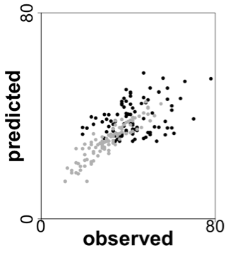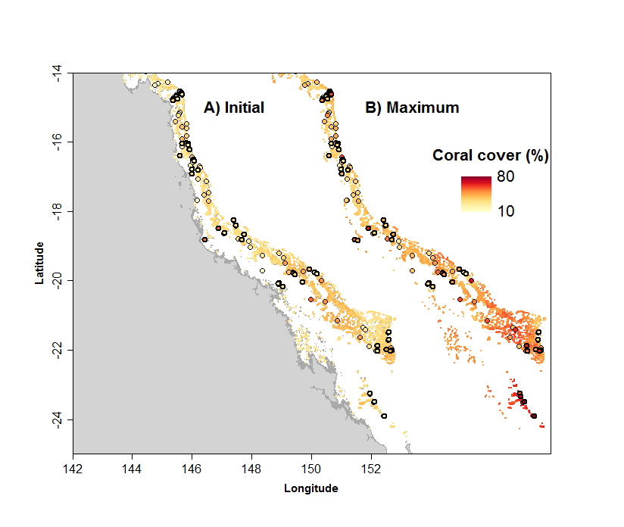

Figure 1. Boosted regression tree predictions of initial (1996) and maximum coral cover across the Great Barrier Reef. Dots show observations used for model calibration (thick outline) and for model validation (thin outline). Inserts show independent model validation on the manta-tow dataset (predictions vs. observations) for both initial (grey) and maximum (black) coral cover.

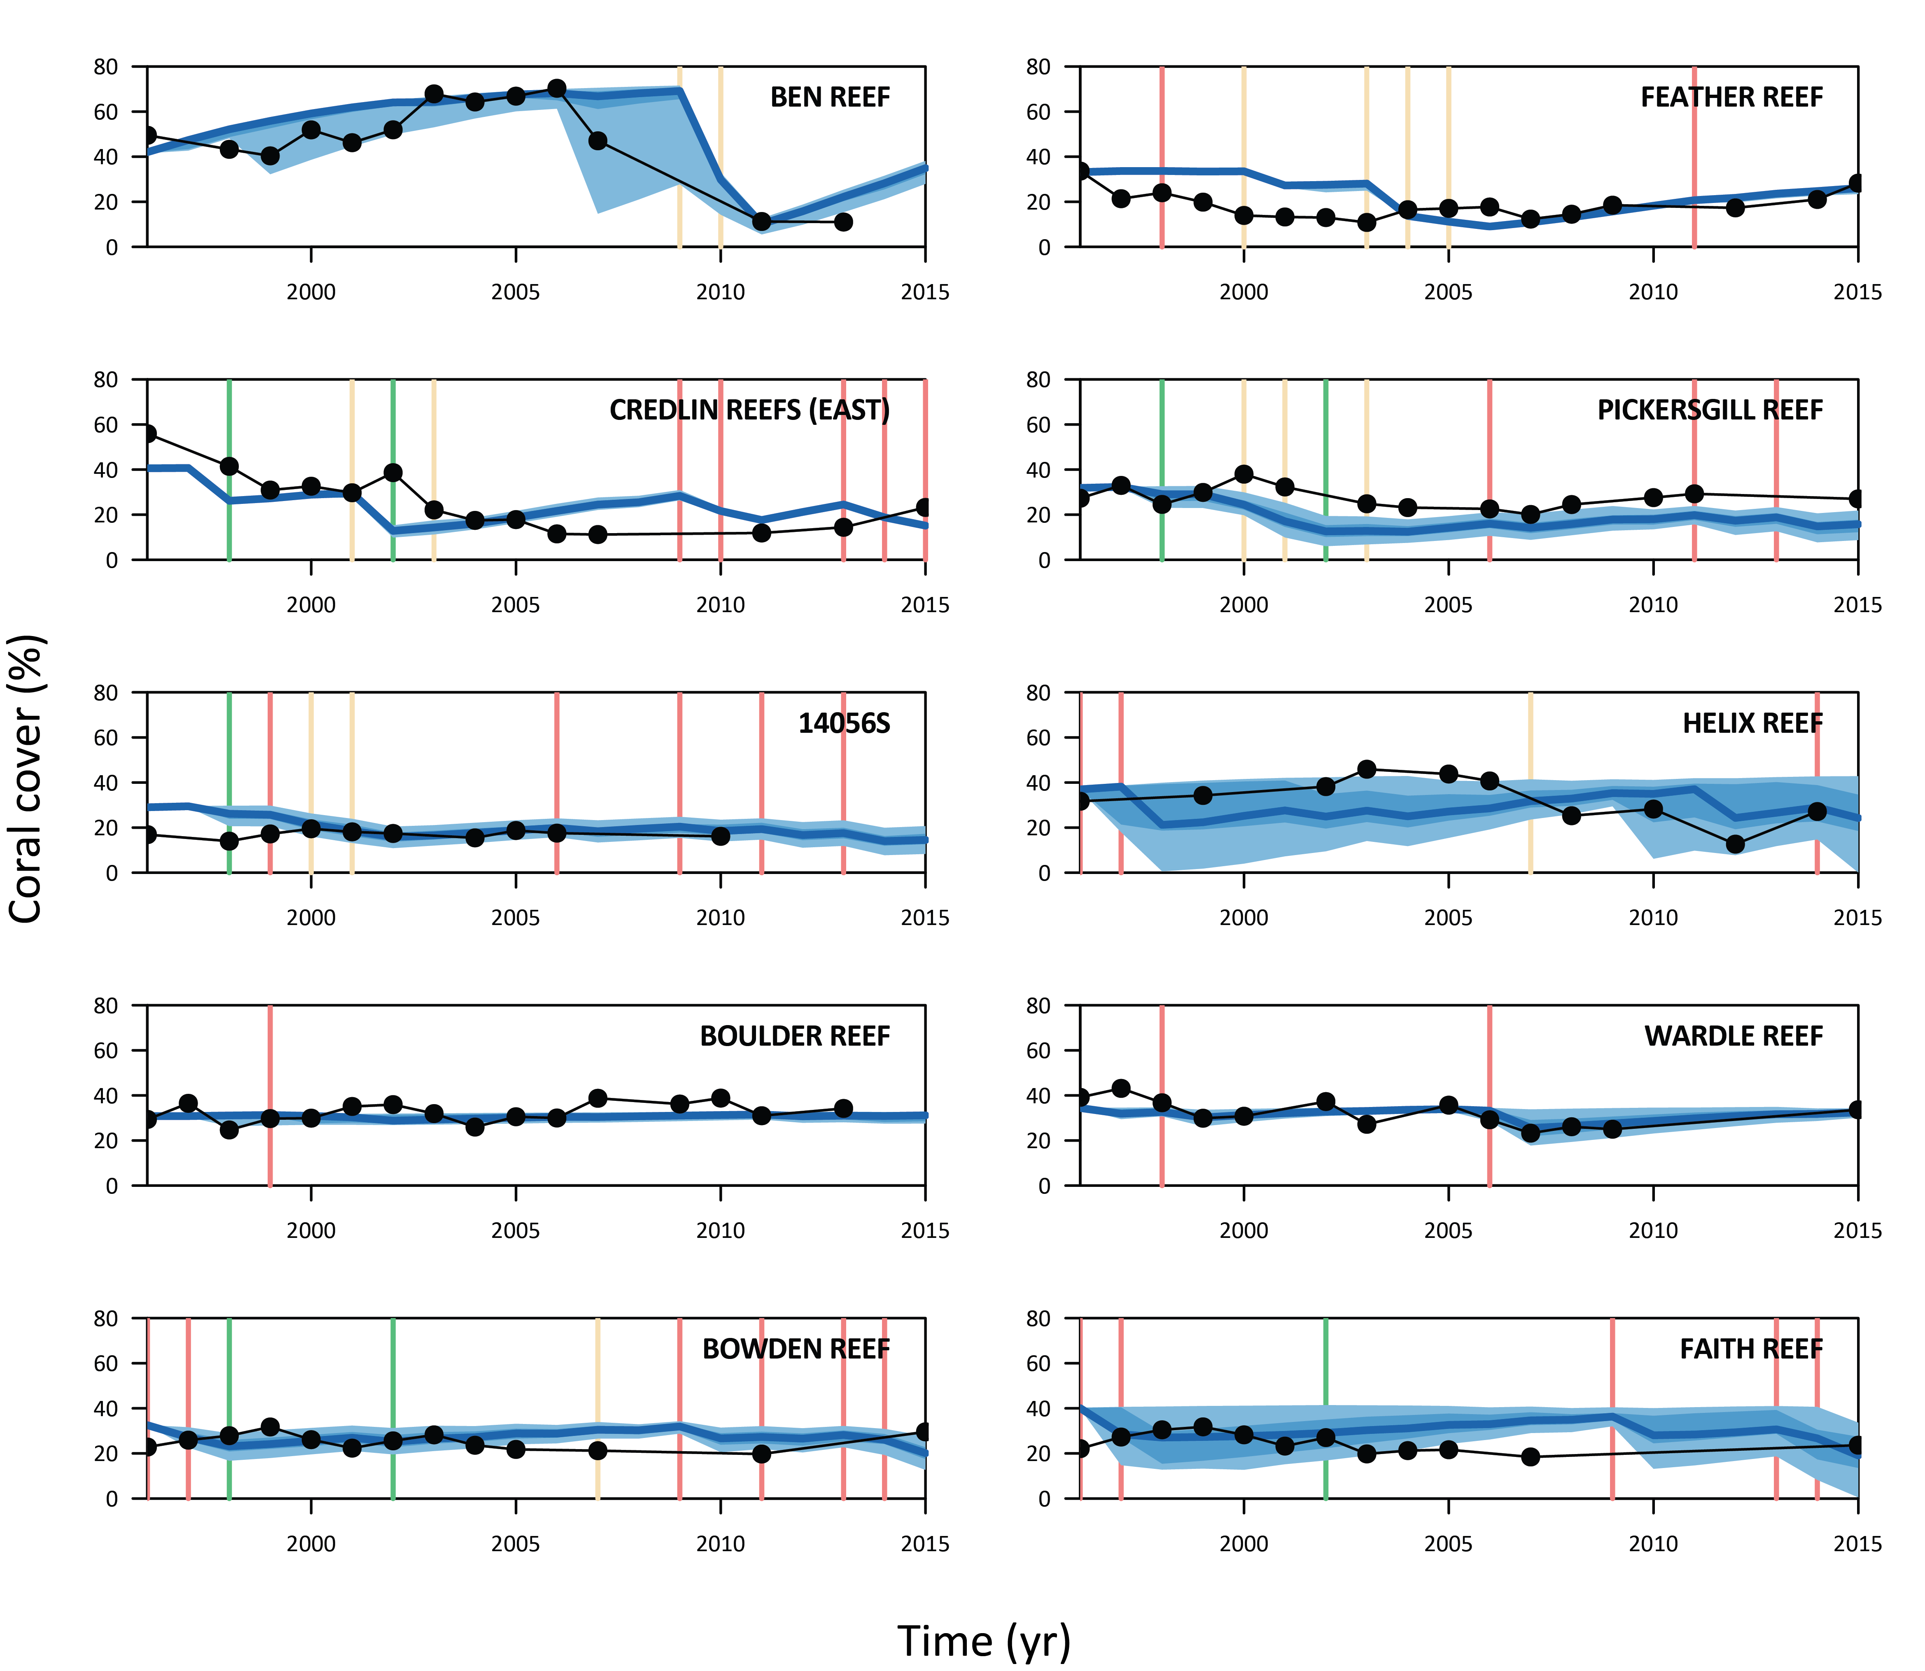

Figure 2. Model validation: predicted trajectories of coral cover (blue envelopes) compared with independent observations (black dots) for manta-tow reefs. Light blue envelopes indicate the 95% confidence interval; medium blue envelopes show the interquartile range (25th and 75th percentiles), and the dark blue line shows the median. Vertical lines indicate disturbances with green = coral bleaching, orange = *Acanthaster planci* outbreak, red = cyclone.

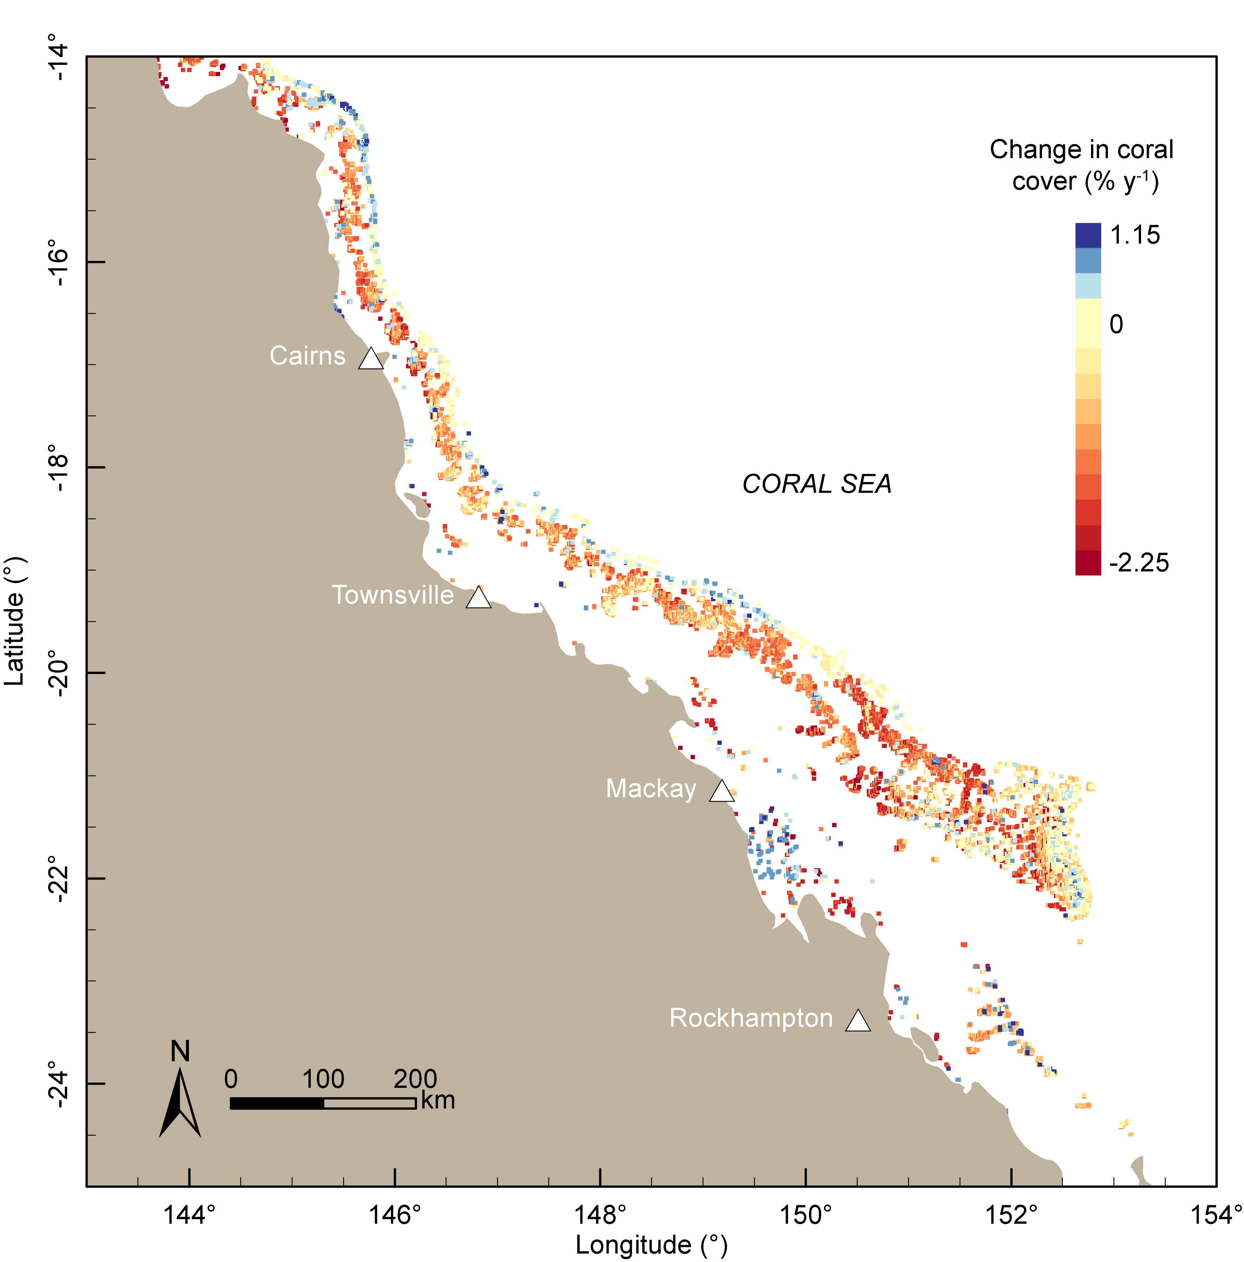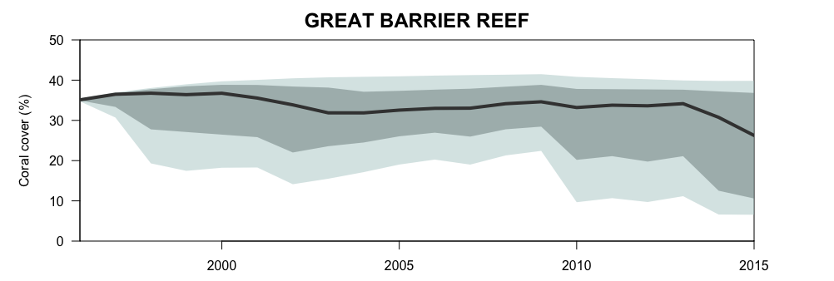

Figure 3. Annual change in coral cover on the Great Barrier Reef between 1996 and 2015. The top panel shows mean predictions of coral cover averaged across the entire Great Barrier Reef. Envelopes indicate the 95% confidence interval (light hue); the interquartile range (medium hue), and the dark line shows the median trajectory. The bottom panel shows predictions of the mean annual rate of change mapped at a 0.01° resolution (% y-1).

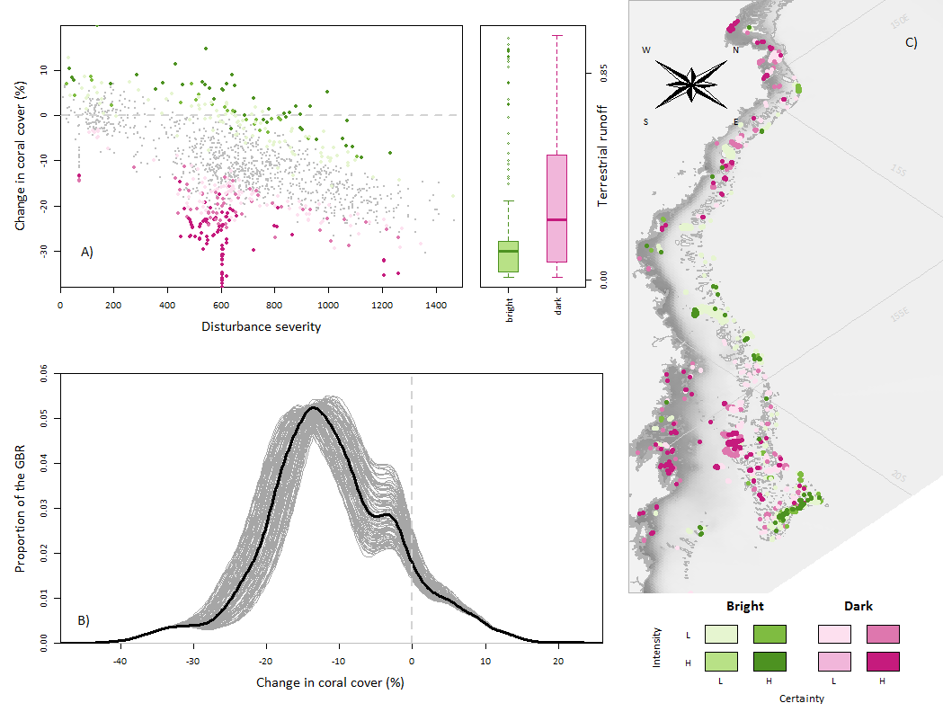

**Figure 4**. Coral resilience bright spots (green) and dark spots (purple) and associated uncertainty.

(A) Resilience bright spots correspond to areas where the decline in coral cover was lower than expected based on the combined severity of coral bleaching, *Acanthaster planci* outbreaks and tropical cyclones and based on the benthic community. Dark spots are areas where the decline in coral cover was greater than expected. The regression line shows the predicted relationship between disturbance severity and extent of coral decline (generalized additive model) in each 1x1km grid cell (N=16035), and the envelope indicates the 90% prediction interval.

(B) Sensitivity analysis quantifying the uncertainty in coral decline based on disturbance frequencies. The thick black line shows the current trend, obtained with modelled disturbance frequencies matching the observed ones. The thin grey lines (N=100) resulted from a variation in bleaching, *A. planci* and cyclone frequencies by ±10%.

(C) Spatial patterns in coral resilience and location of bright and dark spots, based on their respective intensity (defined from A) and certainty (defined from B).